PRESS KIT

16. Blechexpo

from 07. – 10. November 2023 in Stuttgart

AMADA at the Blechexpo 2023

Innovating for the future
Experience the latest capabilities in the sheet metal processing world live AMADA will be presenting its current technology highlights from 7th to 10th November at the 16th Blechexpo in Hall 3, Booth 3201-2.

Faster, more efficient and more reliable – this fall, AMADA will once again demonstrate what customers can expect from top-class sheet metal processing at the world-renowned industry event, Blechexpo, which will be held in Stuttgart, the capital of the German state of Baden-Württemberg. Here, industry visitors to the AMADA booth in Hall 3 will be able to discover the latest innovations right before their eyes.

This year’s highlights will include, for example, the 6 kW VENTIS-3015AJe fiber-laser cutting machine, which ensures perfectly harmonized automation when used in combination with the modular, adaptable ASFII 3015 EU loading and unloading tower. True to the motto of “Productivity not laser power”, the VENTIS offers outstanding performance combined with low energy consumption. Sustainability is also showcased in the latest generation of EGB press brakes, represented at the event by the EGB-1303ATCe. This new series of fully-electric presses possesses a high-precision, oil-free drive. One particular feature of the EGB-1303ATCe is the new backgauge with three independently positionable gauge fingers and six independently controlled axes that make it possible to overcome the restrictions that previously limited the available gaging positions.

November 2023

PRESS ARTICLE 1

AMADA VENTIS AJe with 6 kW

Productivity not power

With its 6 kW fiber laser, the AMADA VENTIS-3015AJe offers all users who work in the world of laser cutting a whole range of new capabilities in terms of the variety of materials that can be cutted, cutting quality and production speed. When used in combination with automation modules such as the AMADA ASF II 3015 EU tower storage system, it provides far greater productivity than systems equipped with more powerful lasers.

One highlight of this year’s Blechexpo in Stuttgart will be the AMADA VENTIS-3015AJe with its single 6 kW laser module. As one of the new generation of fiber laser cutting machines, it is the successor to the 4 kW version and offers even better performance thanks to the higher laser power and optimum beam quality.

Uniquely intelligent

The AMADA VENTIS-3015AJe 6 kW is characterized by its intelligent laser system. Among other things, this makes use of AMADA’s LBC technology, in which the laser beam moves from side to side in different trajectories around a defined cutting point. This brings about concrete advantages during cutting, such as the ability to widen the cutting gap. Even thick materials are optimally fused by the side-to-side movement, meaning that they can be ejected downwards with cleanly cut edges and free from any burr. Thanks to the AMADA LBC FastCut function, the LBC also makes it possible to cut even small hole geometries extremely quickly and accurately without it being necessary to move the entire laser bridge.

Reliable and energy-efficient

The intelligent system achieves ist full productivity when used in combination with automation modules. These include, for example, the tower storage system AMADA ASF 3015 EU II, which will also be on display at the trade fair. It supplies the required raw material, returns cut material to storage, and stands out thanks to its extremely short transfer times. When used in this configuration, the AMADA VENTIS-3015AJe 6 kW once again far surpasses other systems with significantly higher laser power. Its relatively low energy penetration ensures reliable, lowwear production, while also naturally permitting greatly reduced energy consumption.

Autonomous operation

In practical applications, the automated system is perfectly capable of working almost autonomously for periods of several days. In such scenarios, operation is ensured by the Laser Integration System (LIS). As a result, the system continuously monitors itself and automatically adapts all the parameters for the current cutting process. And the LIS Option Pack with fully-automatic nozzle centering and the iCAS function for remnant sheet measurements boosts process reliability even further. The AMADA VENTIS-3015AJe 6 kW is controlled via the new outstandingly userfriendly AMADA VPSS controller.

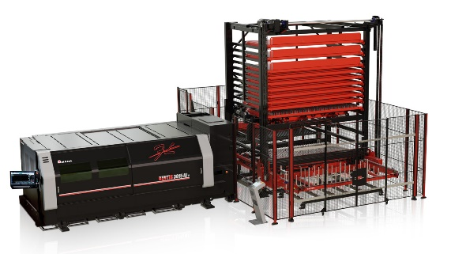

November 2023

PRESS ARTICLE 2

AMADA EGB ATC

A new level of electrical excellence

At Blechexpo 2023, AMADA will be presenting its latest outstanding innovation in the field of electrically-driven press brakes in the form of the AMADA EGB-1303ATCe. Thanks to a host of new features and functions, the machine operates particularly quickly and reliably, opens up a new range of applications and excels through its simple handling and operation.

The AMADA EGB-1303ATCe represents the most recent generation of electrical, servo-controlled press brakes. On the one hand, the system’s servo-electric drive permits extremely high approach and opening speeds, while simultaneously generating the high torque required to achieve the 130 tonnes of press force. At the same time, it also ensures the machine’s exceptionally high positioning and repeat accuracy. In addition, the compact motor permits simplified machine construction and improved maintenance possibilities. Another advantage lies in the fact that the servo-drive does not need any hydraulic oil and has only low CO2 emissions.

Fast, reliable and precise

The automatic tool changer (ATC) has also been redesigned. Its capacity has been increased by 30 percent. At the same time, the new ATC also takes up significantly less space than the previous model. The die size has now also been increased to V50. This makes it possible to process thicker sheets and thus, more generally, a wider range of parts. Another highlight: The AMADA EGB-1303ATCe has an innovative backgauge with three gauge fingers which can be controlled independently of one another. This simplifies component positioning even when processing highly-complex external contours. Further important benefits are provided by the AMADA BI-S II angle measurement system, which can now complete the measuring process in half the cycle time required by the previous model. This now takes just three seconds, equating to considerable time savings during production. The integrated automatic crowning system also contributes to the particularly high component quality. With its two independently controlled servo-electric drives, it is able to compensate precisely for the sagging of the press beam.

Customized ease of operation

The AMADA EGB-1303ATCe is controlled using the new AMADA AMNC controller. As a result, system operation can be customized in either Full or Lite mode using the simplified user interface. It can therefore be used without difficulty even by inexperienced operators. The controller’s enlarged display, the additional mobile control tablet and the live camera image, which uses AR technology to combine the real image with the drawing of the workpiece and the correct stop position, all help improve ergonomics and operator comfort. What is more, the created bending angles are automatically displayed after the bending process, meaning that no time-consuming manual post-bending measurements are required. The AMADA EGB- 1303ATCe will be available as of 2024.

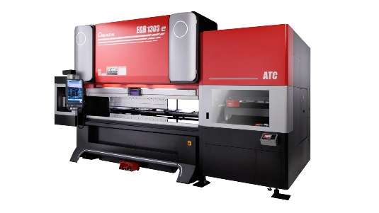

November 2023

PRESS ARTICLE 3

AMADA HRB-5020

Optimally designed press brake

With the innovative LITE mode, the Auto-Crowning (A.C.) system, optimized dimensions and no end of other optional features, the AMADA HRB series of press brakes ensures state-of-the-art ergonomics coupled with optimum production efficiency.

AMADA will also be exhibiting its AMADA HRB-5020 press brake at this year’s Blechexpo in Stuttgart. This is the most recent development in the field of hydraulically- driven press brakes and, together with a number of larger models, constitutes the new generation of machines that are taking over from the proven AMADA HFE3i series. Just like all the new AMADA press brakes, particular emphasis was placed on user-friendliness and an ergonomic design during the development of this system. For example, the associated AMNC 3i controller includes an innovative multi-touchscreen user interface. The system can be operated in FULL or LITE mode. The latter mode was specially designed for inexperienced users and has been pared down to the most essential functions.

Constant bending angles, extended dimensions

At the same time, the AMADA HRB-5020 also showcases the latest technical functionalities and features that AMADA is now offering for its press brakes. One example is the so-called Auto-Crowning (A.C.) system that is optionally available for the system. This compensates for the sagging of the upper press beam and consequently ensures constant bending angles even for long bended parts. The AMADA HRB-5020’s optimized dimensions and measurements also bring about significant advantages in practical operation. For example, the openings have now been extended to 520 mm in order to accommodate even large tools. The cylinder stroke has also been extended to 250 mm and the frame gap at the side frame is now 450 mm. Last but not least, the AMADA HRB-5020 can also be equipped with numerous options that impressively further enhance ease of operation and manufacturing efficiency.

A range of features for even greater efficiency

Other features include, for example, the AMADA SF 75 sheet follower. With a capacity of 75 kg per arm, it greatly assists operators during the processing of large and/or heavy parts. The automatic sliding foot pedal, which is now newly available for the AMADA HRB series, also simplifies operation. And last but not least, the optional equipment available for the press brake also includes the active angle measurement system. Like all the systems in the AMADA HRB series, the AMADA HRB-5020 also excels through its low energy costs and unsurpassed process stability. However, for anyone who wants to manufacture even more efficiently: The AMADA HRB press brakes can also be automated by retrofitting them with a robot system.

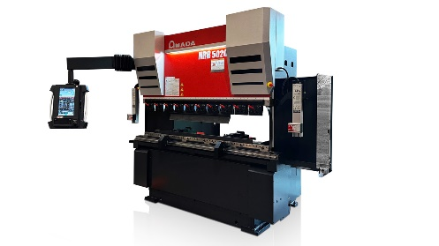

November 2023

PRESS ARTICLE 4

AMADA VPSS

The latest generation

With its automated processes, innovative functions and AI-assisted
features, the new AMADA VPSS CAD CAM software solution is making
production even simpler, more reliable and more efficient.

The AMADA VPSS software is available with immediate effect and constitutes the most recent version of the Virtual Prototype Simulation System. It offers not only even greater ease of operation, but also a whole range of new functions. These include the Tube Solution Pack, which has now been integrated to permit tube and profile machining, together with the automatic creation of parts and nesting plans and the generation of NC codes. This means that all AMADA technologies are now brought together in the VPSS software.

Fully-automatic programming

For the first time, AMADA VPSS now also incorporates the fully-automatic, enormously time-saving import of 3D files, including the automatic creation and processing of sheet templates. It also provides the AMADA Full Auto Blank function. It supports the fully-automatic import of production plans and creates cross-machine nesting plans on the basis of these. The ACSD function is also completely new. This makes it possible to convert parts data present in the form of CSV files from an ERP system into a 3D SEM file that can, in turn, be used for the fully-automatic generation of bending programs. Other innovations include the LBC Flash Cut function for cutting small, round holes using the laser optics and the Soft Joint function. This permits the simple clamping of components without the need for strips and consequently greatly reduces reworking at the component. The function is available on the VENTIS 6 kW and REGIUS 12 kW.

Intelligent support

The new AMADA VPSS is rounded off by AI-assisted features such as the AI Bend function, which makes use of existing bending programs to generate production proposals – irrespective of whether the programs were created manually, automatically or at the machine. AI Drawing Assistance is another AI-based feature. This supports the import of PDF files, which it then automatically completes before transferring them to the AMADA 2D CAD system. This is now integrated as a standard module in AMADA VPSS.

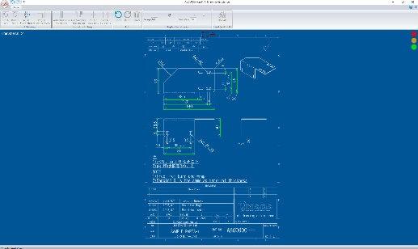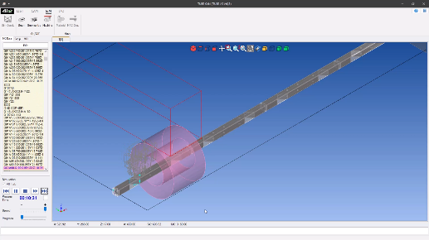

About AMADA GmbH
The AMADA Group is one of the world's leading manufacturers of sheet metal processing machines. AMADA GmbH offers a comprehensive range of cutting, bending, welding, punching and laser technologies. Modular automation components, software applications and a large range of tools complete this offer. In addition, AMADA offers its customers a wide range of services. The AMADA Group was founded by Isamu Amada in Japan in 1946. The German subsidiary AMADA GmbH has existed since 1972.

Additional information:

AMADA GmbH

Amada Allee 1
42781 Haan - Germany

marketing@amada.de
www.amada.de

Bei Vervielfältigung bitte Belegexemplar beifügen.

