PRESS KIT



2024 – From 22nd- 25th October 2024, Hanover

AMADA at EuroBLECH 2024

Growing together with our customers

When EuroBLECH, the industry’s flagship trade fair, opens its doors in Hanover from October 22nd to 25th, 2024, visitors will be able to experience the innovative solutions and full-range strategies that AMADA offers its partners.
Under the motto “Growing together with our customers”, AMADA will once again demonstrate just why it is the perfectly positioned partner to actively shape the future of sheet metal processing for and with its customers. To do this, AMADA will present its wide portfolio of innovative solutions at the 27th EuroBLECH international technology trade fair, where it will occupy booths D06/F06 and D02/F02 in Hall 12. From laser cutting and stamping, through bending and welding and on to automation solutions, visitors at the live demonstrations and specialist discussions will have access to a range of in-depth insights. And they can be secure in the knowledge that AMADA’s experts always focus on finding the best possible way to help customers achieve their objectives. Whether by combining different technologies or using forward-looking solutions for the digital transformation (DX) and Artificial Intelligence (AI) – AMADA is always driven by the vision of exceeding its customers’ production expectations. At the same time, the company does not concentrate only on finding the best possible technological solution, but also focuses on the issue of sustainability and takes account of the imperatives of environmental protection during its development work.
As you would expect from a good partnership, service also plays an important role at AMADA. That is why, at EuroBLECH, the company will be explaining how its European service structure is to be redesigned in order to further enhance its already high quality level. What is more, visitors will have access to first-hand information about the benefits and synergies that will result with immediate effect from the new Welding Technology Center in Italy. So anyone who wants to discover how they can continue to grow in the market together with AMADA in the future should not fail to schedule-in a visit to our stand at EuroBLECH.

Come and visit our booth!
Details about AMADA in EuroBLECH :
https://euroblech.amada.de
Hall 12
Stands D06 and F06
22nd to 25th of October 2024, Hanover, Germany
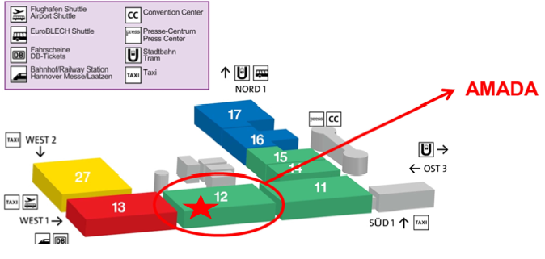
CONTACT US
Information Desk
+49 2104 2126 – 900

PR: AMADA Blanking Technology
October 2024, page 1

PRESS RELEASE 1

AMADA INTRODUCES NEW LASERS AND FEATURES FOR INCREASED PROFITABILITY

To better serve customers’ needs in an increasingly competitive environment, AMADA will unveil new versions of the successful REGIUS / VENTIS / ENSIS fibre lasers and the EM ZRT benchmark punching machine at EuroBlech 2024.

New, in-house designed and manufactured fibre laser engines utilizing industry leading, multi kilowatt single diode modules will be exhibited with higher efficiency, higher productivity and increased profitability possibilities for customers. These will be combined with AMADA’s original beam control technologies, AMNC 4ie control for easier operation and the Laser Integration System (LIS) functions for more autonomous processing.

The ultra-high-acceleration 3-axis linear drive REGIUS-3015AJe, utilizing AMADA’s Variable Beam Control technology for stepless laser beam shape alteration, has a 26kW, twin module AMADA fibre laser engine to show new processing possibilities in the mid-thick material range. Changing the beam shape almost instantaneously between piercing and cutting allows the correct beam properties to be used during all stages of laser processing.

The new 9kW VENTIS-3015AJe has similar performance to 10-12kW solid state lasers thanks to AMADA’s Locus Beam Control (LBC) Technology and 9kW single diode module engine. Easy processing of various thick mild steels, very high speed aluminium processing and the LBC Flash Cut system for ultra-high-speed small hole processing will benefit many customers. The manufacturing cell will feature a compact double tower storage system with 34 shelves, increasing lights-out possibilities.

The new ENSIS-3015AJe with Variable Beam Control technology, will exhibit a 15kW single diode module engine, giving the highest laser beam quality in the sector. AMADA’s Fiber Silky Cut system provides stainless steel cutting possibilities comparable to CO2 lasers, useful for those in the medical and food sectors. The machine will be combined with a single automation storage tower and new TKII part removal system with increased picking capabilities and a label printer, allowing part identification to be automatically applied after laser cutting but before removal from the sheet.

AMADA’s proven LIS automates previously subjective, manual operator tasks such as nozzle condition check, nozzle centring and focal position confirmation, bringing higher autonomy and increased uptime. Automatic head collision recovery and protection glass monitoring further enhance these high specification machines.

PR: AMADA Blanking Technology
October 2024, page 2

AMADA’s class leading, 30T electric servo drive EM-3612ZRTe punching machine includes an automatic tool storage unit with a capacity of 300 tools and 600 dies. With a fully brush covered lower tool turret and unrivalled forming capabilities, the EM-3612ZRTe is a highly productive offering, especially when paired with AMADA’s compact automation modules and tooling solutions. Scratch-free processing possibilities become reality due to the unique lower die mechanism. This machine will be linked to AMADA’s ID TOGU tool grinder which provides an intelligent link between tool maintenance and automatic die height setting on the punching machine to extend tool life.

All the new AMADA blanking machines exhibited at EuroBlech 2024 will feature the AMNC 4ie control, making the machines easier to use with functions such as facial recognition and maintenance instructional videos. Seamless connectivity with AMADA’s V-factory and IoT service solutions provides further opportunities to increase uptime and productivity.

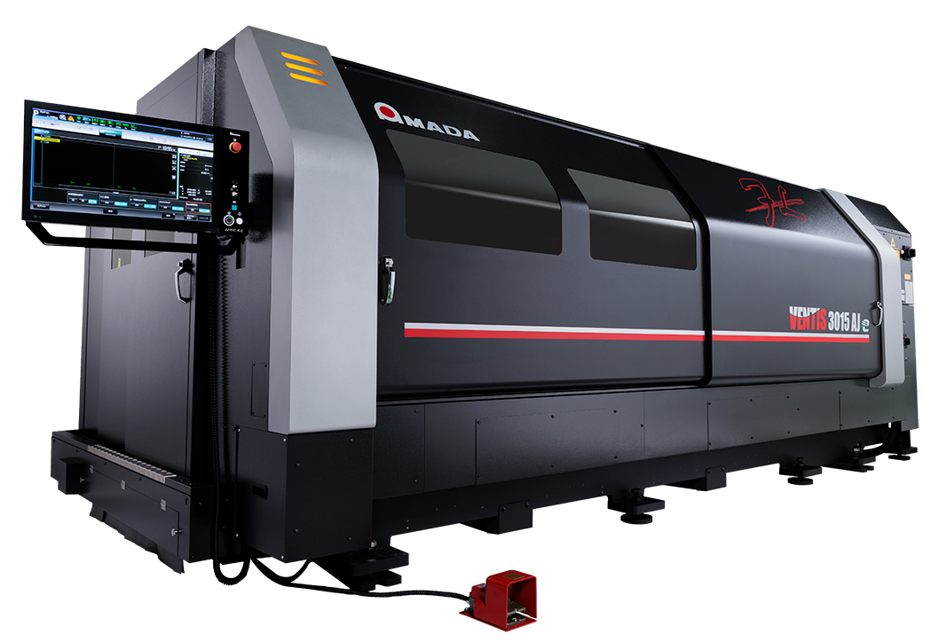
Illustration

Photo credit: AMADA Europe

PR: AMADA Bending technology
October 2024, page 1

PRESS RELEASE 2

AMADA INTRODUCES A HYBRID LINEUP OF SERVO-ELECTRIC AND HYDRAULIC PRESS BRAKES

Building on the success of the EG bending machine, AMADA has developed a new series of servo-electric press brakes. These range from ergonomic and standalone benders, available with or without an automatic tool changer, to robotic models. This new range of machines complements the existing HRB hydraulic series, a well-established product that is perfectly suited to customers' usual production needs.

The servo-electric EGB series is a premium product designed to meet high customer requirements. It aims to be highly productive and accurate while remaining user-friendly, even for less experienced operators. The new EGB-ARse bending cell is fully automatic, requiring the operator only to load the parts to produce and unload them when completed. This maximised machine output increases company profits, and simplifies the operator’s work.
AMADA achieved it through various devices that support the operator during all work phases, from automatic offline programming to innovative technological solutions that overcome traditional bending limitations.

The HRB series is a flexible machine that can be adapted to customers' production needs, adding accessories such as the angle indicator for in-cycle bend angle adjustment, an automatic sliding foot pedal, sheet followers, and an active crowning system to achieve good linearity even with non-standard bending condition. All solutions are designed to simplify the operator's work while increasing productivity.

The EGB series features the new AMNC 4ie numerical control, which is faster and has a larger display. It includes functions such as automatic facial recognition, autonomous setting of customised configurations, voice commands, and an idle stop function to minimise energy consumption when the operator is absent.

The EGB4010e is a compact machine, specifically designed to produce small and complex components. The chair, front table, side shelves and new AMADA Tool Setup Assistant are designed to provide the operator with optimal support, ensuring that all necessary items are within reach.

The standalone bending machines, ranging from 60 tonnes and 2 metres to 130 tonnes and 3 meters (the latter with automatic tool changer), are equipped with three fully independent fingers and an automatic asymmetrical crowning device. This electrically operated device allows the operator to make corrections at four points, which is excellent for working with multiple stations and press-side bending. A 360° camera inside the machine shows the theoretical bending position overlaid on the real-time position via a tablet in front of the operator, simplifying the handling of complex parts. The tablet also provides safety instructions based on the current process and shows the actual final bend angle when used with the Bi-S II, enabling immediate quality control without interrupting production.

PR: AMADA Bending technology
October 2024, page 2

The new BI-SiII angle sensor is faster than its predecessor, handles shorter flanges, measures at three points, and corrects the angle to achieve extremely accurate bends by driving the two axes of the upper beam and the two crowning device axes.

The EGB1303ARse bending cell can be equipped with all possible equipment to automate every step. This includes automatic part teaching (required only for new programs), a double loading area with two cameras for part recognition, a loading robot for cycle time optimisation, automatic gripper change, automatic tool change, three rear fingers to align the bending part in each direction, automatic angle adjustment with Bi-S II, and various unloading solutions, from classic pallets to conveyors to automatic pallet change.

All of this is assisted by tablets, which support the operator in setting up the cell and creating and monitoring production.

Through its EGB series, AMADA offers a complete lineup of servo-electric machines to support all types of production needs, increasing customer profitability and simplifying the work of operators with extremely fast, precise, and easy-to-use machines.

Illustration
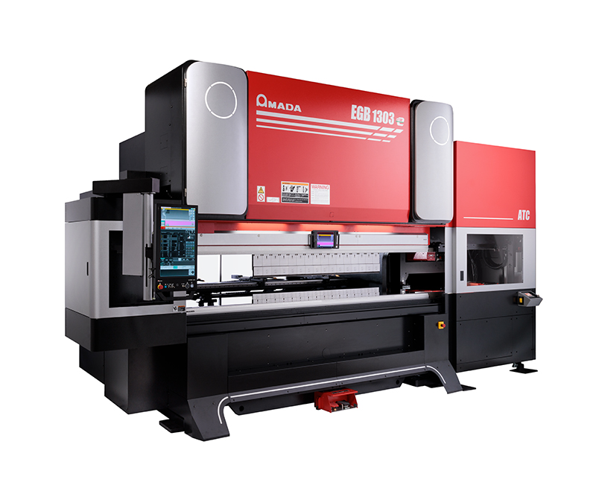
Photo credit: AMADA Europe

PR: AMADA Welding Technology
October 2024, page 1

PRESS RELEASE 3

AMADA WELDING RANGE EXPANSION

With the ability to provide solutions across a wide range of welding applications, AMADA will present several systems at EuroBLECH 2024 covering everything from sheet metal part welding, micro welding, part marking and weld monitoring. There will also be live links to welding facilities in Italy and The Netherlands to show further customer benefits.

The AMADA Group is well known for developing class leading sheet metal processing machinery, but its long history and expertise in various welding fields will be at the forefront of the exhibited machines at EuroBLECH 2024.

The new FLW-Le, mid-range robotic 3kW fibre laser welding cell will highlight features aimed at higher productivity and lower cost-per-part. With a rotating setup table built-in to the protection cabin, throughput is higher as the next part can be prepared while the current part is being welded. AMADA’s original Beam Weaving technology will also be shown, allowing wider gaps in the sheet metal parts to be processed, whilst maintaining a high quality finish. The Teaching Assist System (TAS) and offline VPSS 4ie WELD CAM virtually eliminate manual programming, again increasing machine uptime.

The Jupiter Advanced Laser Welding System is a high-precision laser welding machine known for its exceptional expandability and image processing capabilities. This advanced system is designed to turn individual components into customised systems, making it ideal for a wide range of applications and industries. With its high precision and modular design, the Jupiter system stands out as a premium solution for complex welding tasks.

The Jupiter Resistance Welding System (RWS) for battery packs. This flexible, semi-automatic production system features a parallel gap joint technique to weld battery tabs, ensuring consistent and reliable joints every time. Fully customisable, the Jupiter RWS turns individual components into a system that meets the precise needs for welding high quality batteries in demanding automotive, home energy storage, power tool, electric vehicle, specialised power packs, and military battery module applications.

The laser marking system offers the widest range of marking capabilities in its class. This compact desktop fibre laser marking machine enables part marking and traceability across all industries, from medical devices and automotive components to consumer electronics. Integrated with AMADA WELD TECH’s LM-F Series fibre laser markers, the laser marker can mark metals, plastics, and ceramics, providing high-resolution marking for diverse applications.

PR: AMADA Welding Tehnology
October 2024, page 2

The Laser Process Monitor is the optimal solution for identifying the causes of welding defects and preventive maintenance for laser welding machines. This advanced monitor provides real-time analysis and feedback, enabling manufacturers to enhance welding quality and efficiency. By pinpointing the exact causes of defects, it helps ensure consistent and reliable welding processes, reducing downtime and improving productivity.

Visitors to the stand can see demonstrations of both Jupiter Systems. Experts will be on hand to discuss the variety of Welding technologies.

Illustration

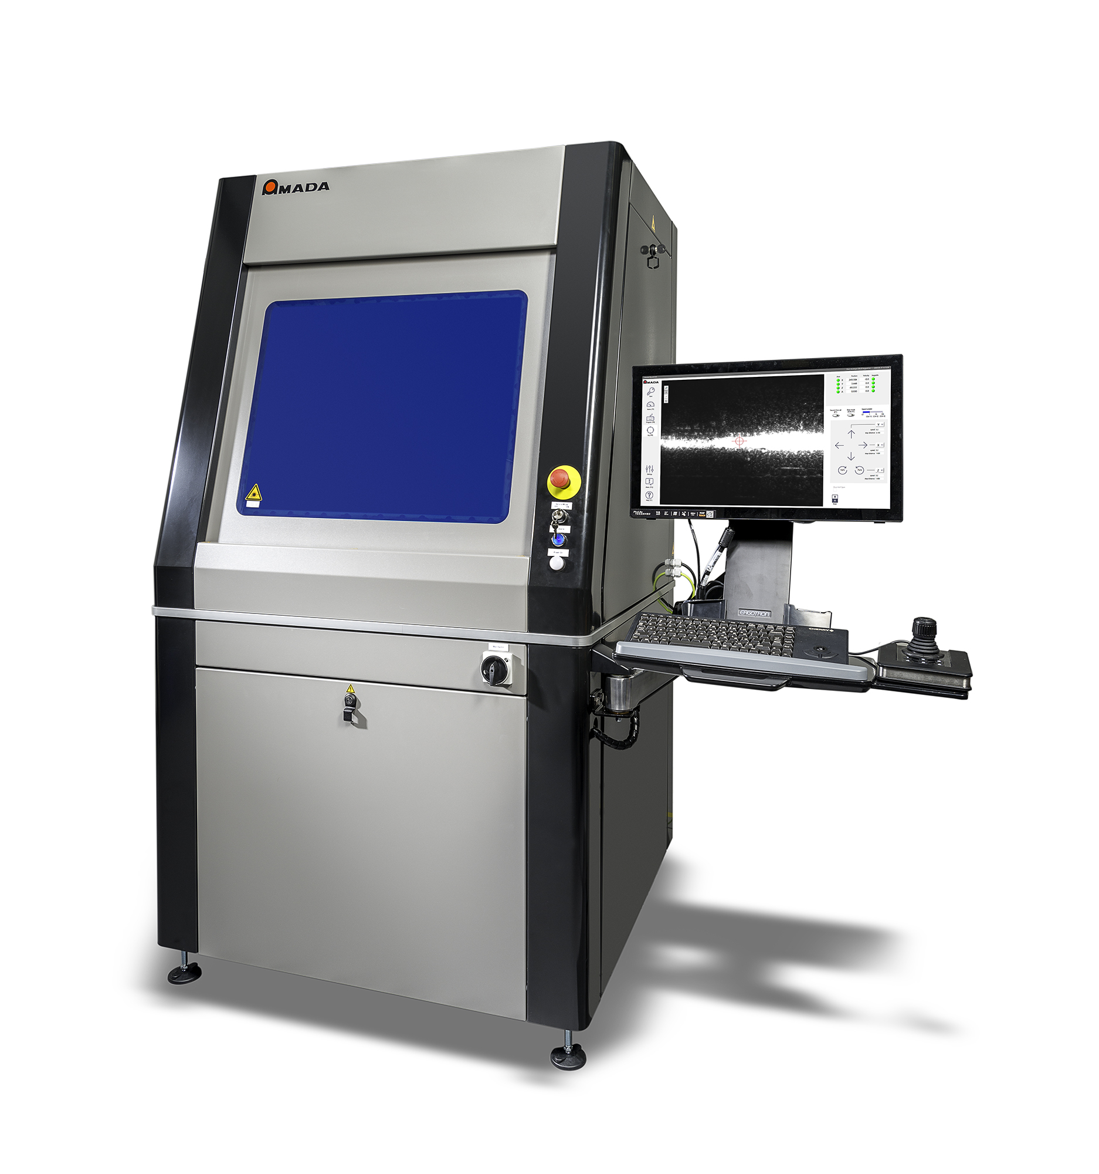

Photo credit: AMADA Europe

PR: AMADA Software solution
October 2024, page 1

PRESS RELEASE 4

AMADA to Unveil INDUSTRY-REVOUTIONISING Software at
EuroBLECH 2024

AMADA, a global leader in the sheet metal fabrication industry, is thrilled to announce the European market debut of its groundbreaking software solution, LIVLOTS, at the upcoming EuroBLECH 2024 exhibition in Hannover, Germany.

Taking place from October 22-25, 2024, EuroBLECH serves as the premier platform for showcasing the latest advancements in sheet metal processing technologies. AMADA's presence at the event will mark a pivotal moment as it unveils LIVLOTS to European audiences, empowering businesses to embrace a digitally transformed future.
At the core of LIVLOTS lies its ability to seamlessly integrate and manage the entire production workflow, from order intake to final product delivery. This comprehensive digitalisation streamlines operations, vastly reduces inefficiencies, and optimises resource allocation, paving the way for unprecedented productivity gains and cost savings.
LIVLOTS represents a paradigm shift in sheet metal fabrication.
By embracing Industry 4.0 principles, we empower our customers to achieve operational excellence and redefine their competitive edge. LIVLOTS is not merely software; it's a gateway to a digitally transformed future.
Key features of LIVLOTS:
- End-to-end process orchestration: LIVLOTS centralises and manages all aspects of production, from order intake to final product delivery.
- Real-time data visibility: Gain real-time insights into production status, machine performance, and material inventory.
- Automated optimisation: LIVLOTS intelligently optimises production schedules, material usage, and machine settings for enhanced efficiency.
- Simple interfacing: Integrate seamlessly with existing ERP and CAD/CAM systems for a holistic workflow.

AMADA at EuroBLECH 2024:
AMADA invites EuroBLECH attendees to experience LIVLOTS firsthand at its booth, where dedicated experts will guide visitors through the software's capabilities and demonstrate its transformative potential.

PR: AMADA Software solution
October 2024, page 2

Illustration

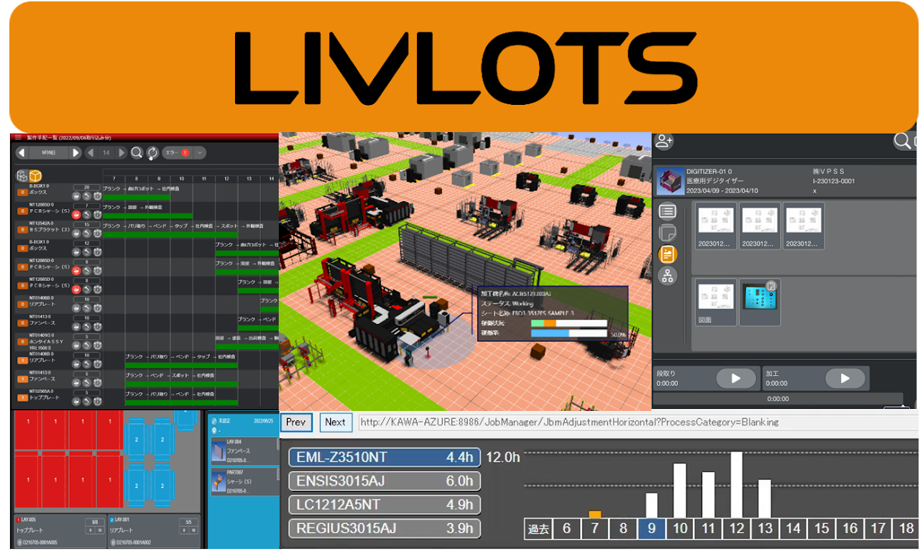

Photo credit: AMADA Europe

PR: AMADA Service
October 2024, page 1

PRESS RELEASE 5

AMADA TO HIGHLIGHT EXPANDED, INDUSTRY LEADING AFTERSALES SOLUTIONS AT EUROBLECH 2024

Building on its already strong customer service and support across Europe, AMADA will present solutions aimed at ensuring all customers receive the same high level of support whatever their location. Enhanced solutions such as AMADA's webshop will make it easy to place orders 24/7. New innovative Proset tooling packages, IoT proactive machine management and improved remote support options, including automatic alarm response, will enhance support to ensure customers maximise their potential.

AMADA’s webshop is a platform that offers a modern and streamlined ordering process that can be used 24 hours a day, 7 days a week. Ordering consumables, tooling and accessories will be possible with the click of a button, at a time and place of your convenience. Order history functionality will allow you to keep track of previous orders and makes repeat orders easy. The order confirmation and tracking function will help with planning and peace of mind.

The IoT DX (Digital Transformation) Service Contract is aimed at those customers wanting to take advantage of the modernity of the digital world. Benefiting from proactive machine management and automatic solution response generation, coupled with remote support, productivity is at the heart of this service.

AMADA tooling solutions offer a market leading approach tailored to maximum productivity. Introducing its new ‘ProSet’ all in one approach that supports the entire tooling package from purchase through to shop floor implementation.

The overwhelming concern from customers in today’s market is the backup and support from the OEM. AMADA Service in Europe is fully customer focused. Leveraging the extensive 500+ strong dedicated service field and support staff they are able to deliver best-in-industry quality of service irrespective of location in Europe and to ensure customers are fully supported through every step of their investment for the full life of the product.

AMADA Service in Europe operates omnichannel communication routes to ensure the minimising of downtime and maximising of productivity. This is achieved by greater digitalisation providing high quality and customised industrial IoT (Internet of Things) services in all markets and territories across Europe for the benefit of end customers.

AMADA’s goal is simple; PROVIDE UNPARALLELED CUSTOMER SUPPORT to ensure all customers reach their maximum potential.

PR: AMADA Service
October 2024, page 2

Existing market leading services available from AMADA include service hubs, service teams for installation/response/planned service, machine relocation packages and training packages. Alongside these Industry 4.0 & IoT, machine/software contracts, tooling for punch press and press brakes and official OEM replacement parts complete the complete service package. All these can be experienced by attendees on our EuroBLECH 2024.

Illustration


Photo credit: AMADA Europe

PR: AMADA Welding Technical Center
October 2024, page 1

PRESS RELEASE 6

AMADA introduces its Welding Technical Center in Italy, Europe's first Fibre Laser Welding FACILITY

AMADA, the world's leading manufacturer of sheet metal fabrication machinery, is proud to announce the opening of Europe's first Fibre Laser Welding Centre, located in Piacienza, near Milan, Italy. This marks a significant step for the European welding industry and underlines AMADA's ongoing commitment to innovation, quality and sustainability.

Innovation and Advanced Technology
The new AMADA Welding Technical Center is designed to be a European technological benchmark. Equipped with the latest fibre laser welding technology, the center will offer advanced solutions for key sectors such as aerospace, medical and electric mobility. The heart of the center will be the 'Weld Vision Hub', an interactive space where customers will be able to observe the advanced capabilities of AMADA's welding solutions closely, ensuring high quality and safety in production processes.

A Co-creation Environment
The center is not only a place for technical demonstration, but also a space for co-creation. Thanks to the synergy between AMADA Italy, AMADA Weld Tech and AMADA Engineering Europe, customers will have the opportunity to work directly with industry experts to develop customised solutions that meet their specific production needs. This collaborative approach aims to inspire new ideas and find innovative solutions that benefit both society and the environment.

Values of Excellence and Sustainability
Inspired by AMADA's values, the new center reflects AMADA's mission to offer reliable and technologically advanced machinery. In addition, the center will be an example of sustainability, with processes optimised to minimise environmental impact, demonstrating AMADA's commitment to a greener and more sustainable future.

An Event Not to Be Missed
The official opening of the Welding Technical Center will take place on Friday 25 October 2024, in conjunction with the EuroBLECH exhibition. During the event, attendees will have the opportunity to explore the center, watch live demonstrations and participate in interactive sessions with AMADA experts.

PR: AMADA Welding Technical Center
October 2024, page 2

Illustration

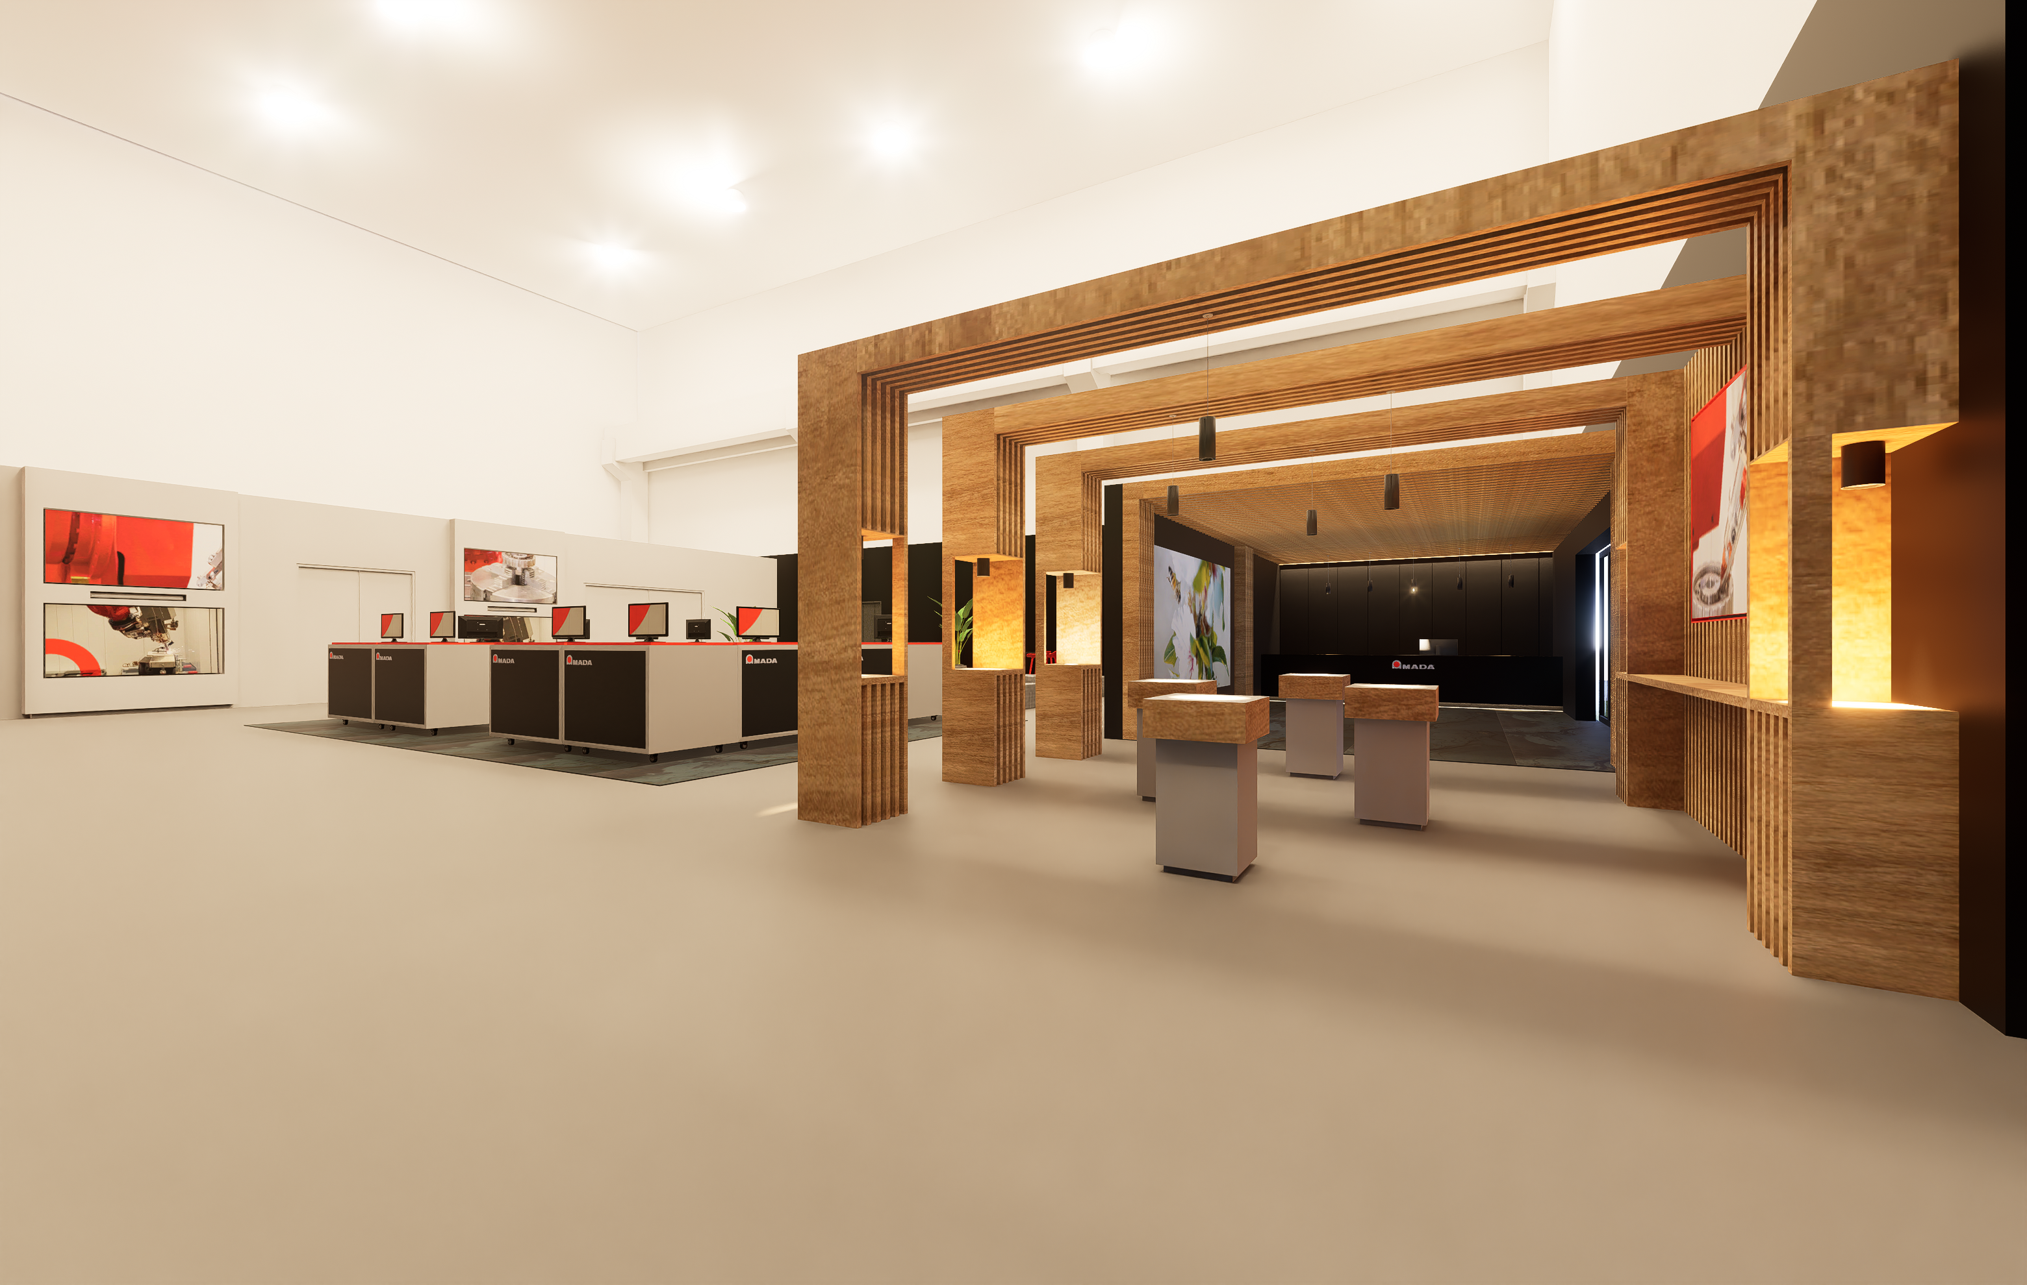

Photo credit: AMADA Italy

About AMADA
The AMADA Group is one of the world’s leading manufacturers of sheet metal working machines. AMADA offers a comprehensive range of cutting, bending, punching and laser technologies. The portfolio is complemented by modular automation components, software applications and a wide range of tools. In addition, AMADA offers its customers a wide variety of additional services. The AMADA Group was founded in 1946 in Japan by Isamu AMADA.
About AMADA Europe
The AMADA Group is one of the world’s leading manufacturers of sheet metal working machines. Founded in 1946 in Japan, AMADA has been present in Europe for more than 50 years. AMADA Europe facilitates the corporate strategy and coordination of the European corporate units. AMADA Europe also ensures that the main brand core values are highly respected at all times: close partnership with customers, innovation, human- and environmental-concerns. With 5 production plants, over more than 30 countries, AMADA’s long-lasting commitment into the leading-edge industrial technologies within Europe is guaranteed.
About AMADA Weldtech
AMADA are a leading manufacturer of equipment and systems for Laser Welding, Laser Marking, Laser Cutting, Resistance Welding, Hermetic Sealing and Hot Bar Reflow Soldering & Bonding. We design and manufacture industry-leading product families for the global market and customize our products around specific micro-joining applications. AMADA’s key markets include medical devices, battery, automotive, solar industry, electronic components and aerospace. AMADA WELD TECH Europe is headquartered in Germany and has additional production facilities in The Netherlands and UK, as well as sales offices in France, Hungary and Italy.
Further information:

 | AMADA GmbH  Amada Allee 1  42781 Haan - Germany  Press Contact:  Kathrin Soroka-Morzinietz  Phone: +49 2104 2126- 311  E-mail: kathrin.soroka-morzinietz@amada.de  www.amada.de |  | AMADA ITALIA S.r.l  Via Amada I., 1/3  29010 Pontenure (Piacenza) - Italy  Press Contact :  Elena Marenghi  Phone : +39 (0)523 872111  E-mail: elena.marenghi@amada.it  www.amada.it
 | AMADA UK Ltd  Spennells Valley Road,  Kidderminster  Worcestershire, DY10 1XS - England  Press Contact:  Cathryn Morris  Phone: +44 (0) 1562749500  E-mail:cathryn.morris@amada.co.uk  www.amada.co.uk |  | 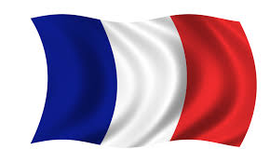  AMADA SA  Paris Nord 2  96 avenue de la Pyramide  93290 Tremblay-en-France - France  Press Contact :  Anissa Soltana  Phone : +33 (0) 1 49 90 30 00  E-mail: asoltana@amada.fr  www.amada.fr
 | AMADA Europe  Paris Nord 2  96 avenue de la Pyramide  93290 Tremblay-en-France - France  Press Contact :  Valérie SALAVIN  Phone : +33 (0) 1 49 90 30 00  E-mail: valerie.salavin@amada-eu.fr  www.amada.eu |  | AMADA WELD TECH Europe  Lindberghstrasse 1  82178 Puchheim, Germany  Press contact:  Ellen Louwers  Phone: +31 492 597 275  Email: ellen.louwers@amadaweldtech.eu  www.amadaweldtech.eu

Please provide evidence copy in the event of reproduction.

