PRESS KIT



2022 – From 25th- 28th October 2022, Hanover

AMADA at EuroBLECH 2022

Innovations For More Efficient Manufacturing

At the industry’s flagship trade fair EuroBLECH, which will be held from 25th to 28th October 2022 in Hanover, AMADA will present new solutions in Hall 12, booth D06/F06 designed to enable its customers to continue to grow in the future.
The focus will be placed on products and concepts that increase productivity while simultaneously boosting cost- and resource-efficiency. Visitors to AMADA’s stand will be able to experience the latest fiber laser solutions aimed at higher productivity with reduced power consumption which improve cutting quality and speeds and are also capable of autonomous manufacturing.
They will also be able to see a welding cell whose enhanced performance permits the machining of thicker materials.
Newly developed, energy-efficient press brake technologies permit improved manufacturing quality and ease-of-use.
The new Blank-to-Bend concept illustrates how punching and combination solutions can be utilized to form a highly-automated cell by means of a rack storage system equipped with robotic press brakes.
AMADA My V-factory Industry 4.0 solutions, IoT Remote Support and a new line control solution demonstrate how users can manufacture more intelligently – and boost their productivity, reliability and cost-effectiveness.

Come and visit our booth!
Details about AMADA in EuroBLECH :
Hall 12
Stands D06 and F06
25th to 28th of October, 2022, Hanover, Germany
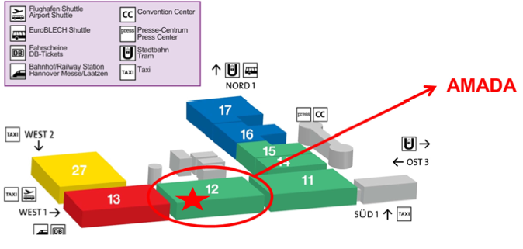
CONTACT US
Information Desk
+49 2104 2126 – 900

PR: AMADA LBC Technology
October 2022, page 1

PRESS RELEASE 1

AMADA LBC Technology

AMADA ENHANCES LBC TECHNOLOGY FOR HIGHER PERFORMANCE AND LOWER CONSUMPTION

In order to keep customers profitable in the increasingly competitive laser cutting market, AMADA will exhibit the new 6kW VENTIS fibre laser featuring the company’s unique Locus Beam Control (LBC) technology at EuroBlech 2022, highlighting its ability to perform like an 8-10kW machine but with lower running costs.

Following on from the success gained since the revolutionary 4kW VENTIS was launched at EuroBlech 2018, providing productivity usually associated with 6kW lasers, this higher power variant will be especially relevant considering energy costs are rapidly increasing. So far, almost 200 orders have been received for the 4kW version in Europe.

The reasons behind this higher cutting efficiency are AMADA’s unique LBC technology and the company’s single diode module, high brightness, fibre laser engines. This combination provides highly efficient material removal and therefore higher cutting speeds vs a standard fibre laser of equivalent power.

Many customers have seen the advantages of AMADA’s LBC technology and its 3 main processing modes: Productivity Mode provides cutting speeds usually associated with higher power lasers when processing with nitrogen, Quality Mode can provide dross free stainless steel up to 15mm (4kW) and 20mm (6kW) to reduce secondary processes and Kerf Control mode is particularly useful when combined with AMADA’s TK part picking systems, allowing the cutting kerf to be widened up to 1mm to ensure reliable automatic removal of components from the cut sheet.

LBC Flash Cut is another revolutionary development which will be shown at EuroBlech 2022. This technology processes the shape by moving only the laser beam without moving the axis, so it can process at an unprecedented speed that surpasses conventional laser machines. Depending on the industry, it has the potential to become an innovative processing method that overturns concepts.

LBC technology allows the laser beam to be moved dynamically in predetermined patterns independent of the laser cutting head. This removes the need to defocus the laser beam, as is the case with all other fibre laser cutting systems, and retains the superior power density of the laser beam, thereby providing faster cutting speeds and higher quality parts. In particular, thick mild steel cutting is a simple process with LBC technology as a very wide range of different material qualities can be processed without adapting the cutting data. This means higher productivity and quality is achievable as machine setup is drastically reduced.

PR: AMADA LBC Technology
October 2022, page 2

AMADA’s 4kW and 6kW, single diode module, fibre laser engines used in the VENTIS series machines achieve very high laser beam density due to the elimination of the combiner module. All multi-module fibre laser engines lose some power density, and therefore performance, when the modules are combined.

The new 6kW VENTIS will be shown with an all-electric pallet changer, allowing customers to experience the benefits of this fibre laser close-up. A 4kW VENTIS will also be exhibited in a fully automated cell in order to highlight the ‘Productivity, not power’ theme. Consisting of the new double tower ASF-EU II Twin load/unload system and TK3015EU part picker, this cell is capable of higher productivity over a 24 hour period than a 15kW standalone laser, with significantly lower average cost-per-part.

The new ASF-EU II Twin load/unload tower, consisting of 18 load and 7 unload shelves, has a revolutionary pallet change cycle that ensures the new sheet of raw material is always kept above the previously cut sheet of parts. This stops the problem of small pieces of scrap falling onto the new raw material sheet before it is sent into the laser, thereby reducing possible cutting defects and machine stoppages. In common with the 1000+ automated AMADA storage systems installed around Europe, the ASF-EU II Twin is retrofittable.

The TK3015EU has proven very popular, with over 100 units being installed in Europe so far. With an individual part picking time of approximately 10 seconds, parts can be removed quickly and reliably in preparation for the next stage of the manufacturing process.

The VENTIS series fibre laser cutting machine is available in 3015 and 4020 sizes, with 4kW or 6kW power sources.
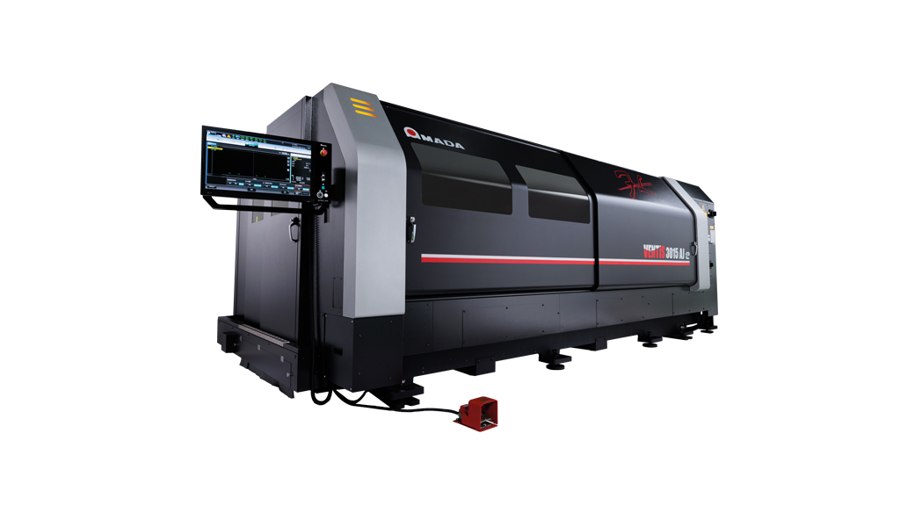

Illustration

Photo credit: AMADA Europe

PR: AMADA Laser technology
October 2022, page 1

PRESS RELEASE 2

State-of-the-art AMADA laser technology

Higher performance, increased productivity

At EuroBLECH 2022, AMADA will be presenting its latest generation of laser cutting systems. These have more powerful beam sources and are able to machine an even wider range of materials quickly and reliably. What is more, despite being more powerful they are also extremely energy-efficient. At the same time, features such as the AMADA LIS system permit intelligent, highly-automated cutting, while the new automation systems make it possible to achieve considerable productivity increases.

Whether it’s the AMADA ENSIS-3015RI with 12 kW, the AMADA VENTIS-3015AJe with 6 KW or the AMADA REGIUS-3015AJe with 12 kW: AMADA has once again increased the laser power of all its fiber laser cutting systems. This performance boost guarantees outstanding cutting quality during nitrogen cutting, even when machining thicker materials. However, it also increases the cutting speeds of the systems and increases the productivity of users, who are now able to manufacture faster and, when an automation system is also used, with fewer personnel.

All the new AMADA laser cutting systems are also equipped with the AMADA Laser Integration System (LIS). As a result, the machines continuously monitor themselves and automatically respond to inputs for the current cutting process. This permits a very high level of autonomous production. The manufacturing results are therefore far less dependent on the operator’s knowledge and experience than in the past. Instead, the entire production process is made simpler and more reliable so it is no longer essential to have highly-qualified personnel on hand.

AMADA welding cells with 6 kW of power

AMADA has also increased the laser power of the FLW-ENSIS fiber laser welding cells to 6 kW. The 6 kW fiber laser, which is available with immediate effect, increases the penetration depth in steel and stainless steel to 12 mm and in aluminum to 8 mm. As a result, components can be fully welded at extremely high speeds without the need for time-consuming weld seam preparation. These machines are suitable for all applications because the AMADA FLW-ENSIS fiber laser welding cells are also exceptionally well suited for soldering processes.

All users of these welding cells benefit from AMADA’s innovative ENSIS technology. Using this, the mode of the laser beam can be automatically changed to best suit the application and material being processed. Another feature is the unique beam weaving technology, in which the integrated rotating optics cause a circular movement of the laser beam. These technologies, in which the integrated rotating optics cause the circular, side-to-side movement of the laser beam. These technologies, which have been exclusively developed by AMADA, take the welding of an extremely wide range of materials to a completely new level and it is now possible to bridge over larger gap sizes than were previously possible using laser welding processes.

PR: AMADA Laser technology
October 2022, page 2

And if that still isn’t enough, the FLW-ENSISsystems are equipped with a filler wire function to cope with particularly large gaps.

New storage and part picking system for AMADA EML-AJ combination machines

At EuroBLECH 2022, AMADA will be presenting a market innovation in the form of the new ASR 3015 PR storage and part picking system. For the first time, this fully-featured system will permit the autonomous loading and unloading of raw material, parts sorting and the storage of the components and sheet skeletons. The system is the most compact automation solution in this performance class available on the market. Material loading / unloading and part removal run in parallel without interrupting machine operation and there is no variation in sheet load / unload cycle times.
When used together with an AMADA EML-AJ punch/fiber laser combination machine, the innovative automation solution can drastically increase the productivity of the overall system. As it is, the productivity level is already high because the 3 kW fiber laser utilized within the EML-AJ already cuts considerably more quickly than a conventional CO2 laser and achieves considerable energy savings while doing so.

Illustration
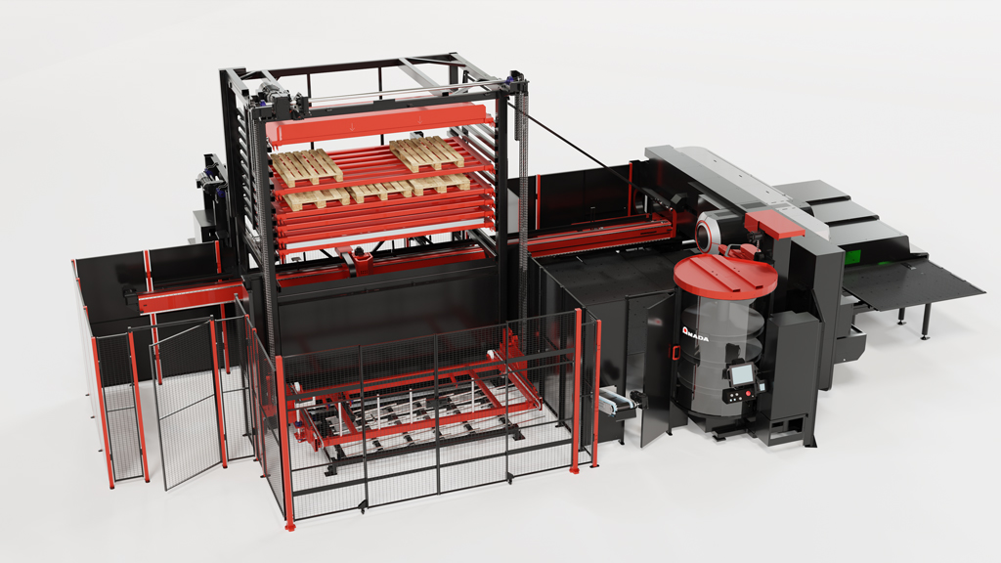

Photo credit: AMADA Europe

PR: AMADA HRB Auto Crowning press brake
October 2022, page 1

PRESS RELEASE 3

AMADA HRB Auto Crowning press brake

AMADA BRINGS HIGHER ACCURACY AND FLEXIBILITY TO MID-RANGE PRESS BRAKE MARKET

With thousands of HF type press brakes installed throughout Europe, AMADA is bringing higher accuracy with the new auto crowning device and enhanced flexibility to its mid-range line-up for the first time. Previously only available on high-end press brakes such as the AMADA HG, the new HRB Auto Crowning mid-range model responds directly to AMADA’s customer demand.

AMADA’s HRB Auto Crowning press brake features a new system, compensating for deflections in the upper and lower beam when pressure is applied, to boost precision for users, and an extended open height of 520mm and stroke of 250mm for all the standard stroke models. The new auto crowning device is CNC controlled through the AMNC 3i control in conjunction with the DigiPro digital protractor device, for an easy and effective process, even for non-skilled operators.

The new auto crowning device brings many advantages to all customers who need higher accuracy in addition to a stable and reliable bending process. Production of kitchen equipment, furniture, electronics, and assembly components are just some examples of parts which can directly benefits from these new features.

The AMADA HRB Auto Crowning machine can also be equipped with an optional automatic sliding foot pedal. When a program has several bending stations along the beam, there is no longer any need to keep moving the foot pedal manually. It is not uncommon for some press brake operators to move the foot pedal 100 times a day, which over a year equates to a lot of wasted time. AMADA’s sliding foot pedal allows automatic movement, boosting productivity.

The machine is available through a wide range of sizes, from 50 tonnes 2 metres up to 220 tonnes 4 metres, including the long stroke versions, which increase the open height from 520mm to 620mm.

Notable retrofittable options available to customers include the AMADA Bi system for in-cycle angle measurement and adjustment. Adopting this solution helps to ensure the elimination of scrap parts, a feature that is particularly useful for companies processing small batches or expensive materials. The AMADA HRB Auto Crowning machine can also be equipped with one or two sheet followers. This device has a payload of 75Kg per arm and is particularly useful in case of large and heavy parts, to support the daily work of the operator, increasing the safety of the whole process.

PR: AMADA HRB Auto Crowning press brake
October 2022, page 2

The AMNC 3i large touchscreen 3D control includes a number of innovative features, including the new ‘Lite’ mode. In effect, Lite mode offers simplification of the HMI, in turn making management of the control quicker and simplifying the introduction of new employees.

The new HRB Auto Crowning press brake is already available for demonstration at AMADA subsidiaries throughout Europe.

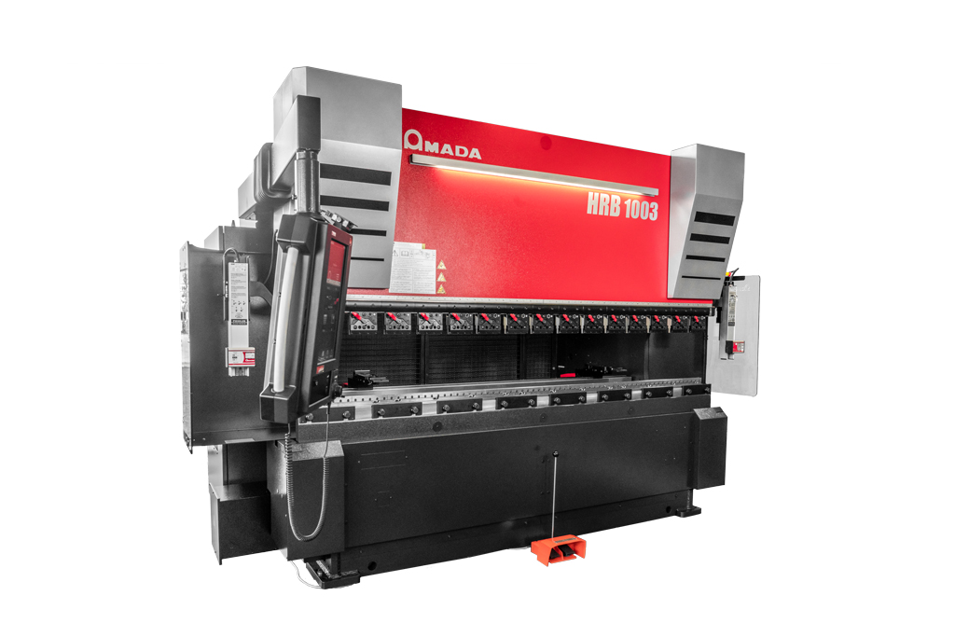
Illustration

Photo credit: AMADA Europe

PR: AMADA RBR solution
October 2022, page 1

PRESS RELEASE 4

AMADA RBR solution

AMADA RELEASES A FULLY AUTOMATIC, RETROFITTABLE BENDING CELL

AMADA developed the RBR fully automatic bending solution as the answer to its customers requirement to produce a wide range of part sizes with a reliable and fast bending cycle, whilst maintaining high quality standards.

AMADA’s RBR series, a fully automatic solution with the possibility to schedule a large production run of different parts, is now available for the European market, The bending cell is equipped with all the appropriate devices to bring the necessary flexibility required by our customers, such as the automatic tool and gripper changers, and the motorised regripping units to support the part manipulation by the bending robot.
From the press brake side, the HRB-ATC series, available both as 100 tonnes 3 metres and 220 tonnes 4 metres, offers the advantages of fully automated production thanks to the automatic tool changer (ATC). The ATC, which is able to reduce the set-up time of the press brake by up to 80% compared to a manual tool loading, is also an essential device to let the operator schedule the requested production without any tool layout restriction. The AMADA HRB-ATC series also features a punch reverse function and automatic crowning – compensating for deflections in the upper and lower beams when pressure is applied – which comes as standard to boost precision for users.
The AMADA RBR series is available with either a 50kg or 200kg payload robots, selectable depending on the needs of the customer’s production. The flexibility of the solution is granted by the support of a wide range of part size, from a minimum of 300x200mm for either robot, up to 2000x1000mm for the 50kg robot and 3000x1500mm for the 200kg version. Subcontract fabricators serving markets such as refrigeration, kitchen equipment, retail display, furniture, and construction, for example, will certainly benefit.
This high level of automation is possible thanks to the offline programming module VPSS 3i ARBEND and the CELL MANAGER scheduling system, Starting from a 3D model of the part to be processed, ARBEND automatically programs the bending cell with just a few clicks of the mouse, while CELL MANAGER organizes the full production autonomously.
The standard configuration includes a loading area, which allows you to load up to 6 stacks of different parts, a thickness detection device, to confirm the pick-up of a single piece before proceeding with the following phases, a reference table, and a customisable unloading area based on different pallet configurations. The motorised regripping unit and automatic gripper changer (AGC), which can store up to nine grippers, complete the standard package of devices. This configuration allows you to schedule any type of part without manual operator setup.

PR: AMADA RBR solution
October 2022, page 2

One notable option is the AMADA Bi system for in-cycle angle measurement and adjustment. Adopting this solution helps to ensure the elimination of scrap parts, a feature that is particularly useful for companies processing expensive materials.
The new RBR series is available for demonstration at AMADA subsidiaries throughout Europe.

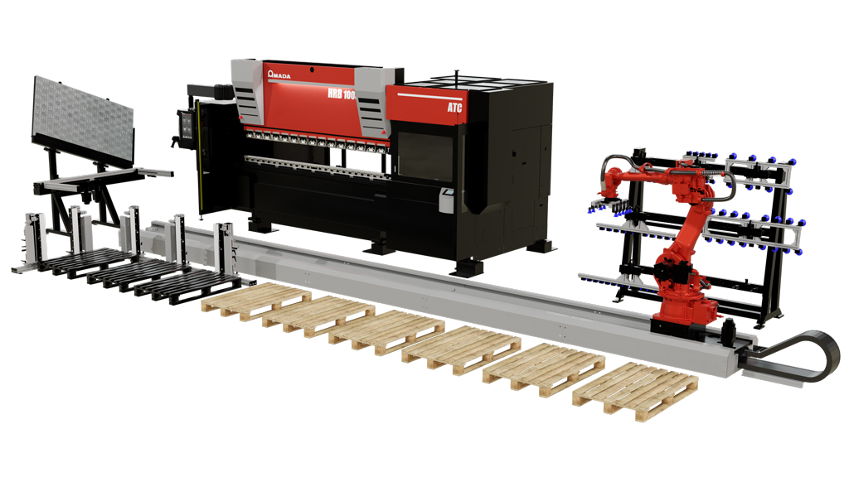
Illustration

Photo credit: AMADA Europe

PR: Software & Service
October 2022, page 1

PRESS RELEASE 5

AMADA Software & Service

Smarter production

My V-factory, IoT Remote Support and a new line control solution are all examples of AMADA’s Industry 4.0 solutions, which allow users to implement intelligent manufacturing– and boost their productivity, reliability and cost effectiveness.

AMADA offers all users new possibilities in the world of fully networked, digitalized 4.0 production. AMADA My V-factory plays a central role in this. This cloud based system displays vital production and machine indicators as the basis for a continuous improvement process that is designed to improve productivity. It is a smart assistance system which allows all users to monitor their entire production environment live at any time, irrespective of their location, thus enabling them to operate their systems in the most productive way possible.
Proactive AMADA IOT Support ensures even more manufacturing efficiency. With this solution, AMADA remotely monitors customers machines, providing support and directly reducing downtimes by remotely accessing the machines as required.
AMADA is currently developing a new smart line control solution for integrated warehouse management. With this, the machine controller is the used to manage a connected AMADA CSII warehouse system. The solution also comprises integration into the central AMADA database and assistance via AMADA IoT Support.

Illustration

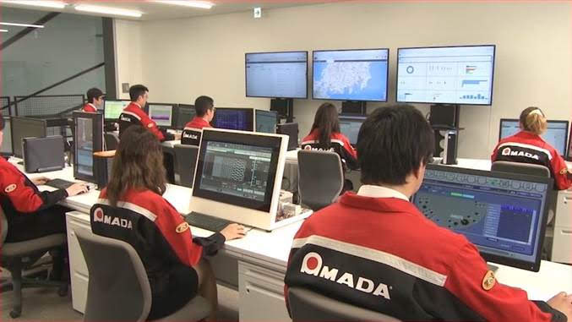

Photo credit: AMADA Europe

PR: Blank-to-Bend
October 2022, page 1

PRESS RELEASE 6

AMADA Blank-to-Bend

Smart networking

With its new Blank-to-Bend concept, AMADA links together punching and cutting systems and automatic press brakes via a warehouse storage system to form a highly automated end-to-end solution.

With AMADA’s Blank-to-Bend concept, it is possible to perform all cutting and bending operations, including material handling, in a single, highly automated end-to-end system for the first time. The concept revolves around the use of the AMADA CSII warehouse storage system. This is connected, for example, on one side to an AMADA punching machine or punching/fiber laser combination machine which creates the cut blank. On the other side, an AMADA HRB-ATC with RBR bending robot solution performs the fully-automated bending operations necessary to produce the finished part.

The Blank-to-Bend concept is of particular interest to AMADA customers that already possess a CSII storage system and an AMADA punch or punch/laser combination machine who are now planning to extend their processes to include bending. Compared to the cost of the overall investment in the system, the financial outlay involved in implementing the concept is very small and the solution is precisely configured to meet the customer’s specific requirements.

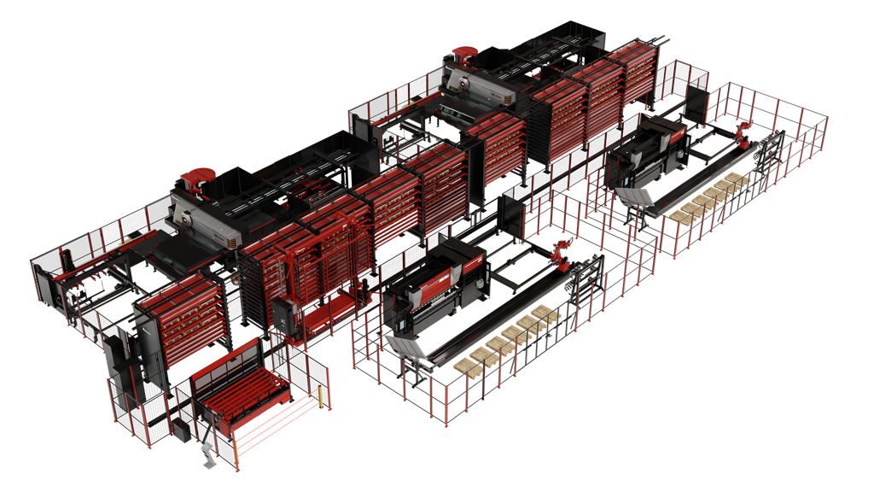
Illustration

Photo credit: AMADA Europe

About AMADA
The AMADA Group is one of the world’s leading manufacturers of sheet metal working machines. AMADA offers a comprehensive range of cutting, bending, punching and laser technologies. The portfolio is complemented by modular automation components, software applications and a wide range of tools. In addition, AMADA offers its customers a wide variety of additional services. The AMADA Group was founded in 1946 in Japan by Isamu Amada.
About AMADA Europe
The AMADA Group is one of the world’s leading manufacturers of sheet metal working machines. Founded in 1946 in Japan, AMADA has been present in Europe for more than 40 years. AMADA Europe facilitates the corporate strategy and coordination of the European corporate units. AMADA Europe also ensures that the main brand core values are highly respected at all times: close partnership with customers, innovation, human- and environmental-concerns. With 4 production plants, over more than 30 countries, AMADA’s long-lasting commitment into the leading-edge industrial technologies within Europe is guaranteed.
Further information:

 | AMADA GmbH  Amada Allee 1  42781 Haan - Germany  Press Contact:  Anne Frankenheim  Phone: +49 2104 2126-0  E-mail: anne.franckenheim@amada.de,  www.amada.de |  | AMADA ITALIA S.r.l  Via Amada I., 1/3  29010 Pontenure (Piacenza) - Italy  Press Contact :  Elena Marenghi  Phone : +39 (0)523 872111  E-mail: elena.marenghi@amada.it  www.amada.it
 | AMADA UK Ltd  Spennells Valley Road,  Kidderminster  Worcestershire, DY10 1XS - England  Press Contact:  Cathryn Morris  Phone: +44 (0) 1562749500  E-mail:cathryn.morris@amada.co.uk  www.amada.co.uk |  | AMADA Europe  Paris Nord 2  96 avenue de la Pyramide  93290 Tremblay-en-France - France  Press Contact :  Valérie SALAVIN  Phone : +33 (0) 1 49 90 30 00  E-mail: valerie.salavin@amada-eu.fr  www.amada.eu
 | AMADA SA  Paris Nord 2  96 avenue de la Pyramide  93290 Tremblay-en-France - France  Press Contact :  Anissa Soltana  Phone : +33 (0) 1 49 90 30 00  E-mail: asoltana@amada.fr  www.amada.fr

Please provide evidence copy in the event of reproduction.

